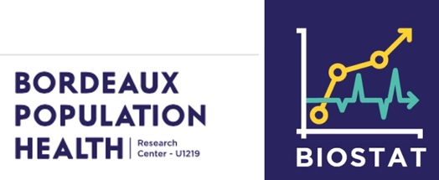

Position for a Master2’s internship in Biostatistics
at the INSERM Institute in Bordeaux - France

We are seeking a highly motivated Master’s student with a strong background in statistics, particularly survival analysis and solid computational skills to contribute to a research project on cancer clinical trials.The internship will take place within the Biostatistics team at the INSERM Bordeaux Population Health Research Center (BPH). The team develops statistical methodology for longitudinal and survival data, dynamic modelling, and clinical research. The project will be conducted in collaboration between Virginie Rondeau (BPH, Bordeaux) and with Professor Ingrid Van Keilegom (KU Leuven, Belgium).
Project context
Informative censoring arises when the censoring time is associated with the event time. In such settings, standard survival methods that assume independent censoring, including the Kaplan–Meier estimator, may produce biased results. For example, patients may leave a medical study because their health is deteriorating or improving, they move to another care setting, discontinue or change treatment, or become too frail to continue. When high-risk individuals are censored early, the remaining risk set may appear artificially healthier, leading to an upward bias in the estimated survival curve. Importantly, dependent censoring is generally not identifiable from standard right-censored data alone.
The central question of this Master’s thesis will be:
How do shared-frailty and copula-based approaches compare for handling informative censoring, particularly when the event model includes time-dependent covariates?
The project will first introduce both approaches in a simple setting, before comparing them theoretically and through simulation studies. It will then apply the methods to a cancer dataset. A key objective will be to clarify the interpretation of the dependence parameter in each framework: a shared frailty represents unobserved heterogeneity inducing dependence between event and censoring processes, whereas a copula parameter often expressed through Kendall’s τ, directly characterises the dependence between the two latent event times.
Candidate profile
Applicants should be enrolled in a Master 2 programme in statistics, biostatistics, public health, applied mathematics, data science, or a related field.
Desired skills include: Strong knowledge of statistical modelling and survival analysis;
- Experience with data analysis and statistical inference;
- Interest in dynamic joint modelling;
- Good programming skills in R;
- Ability to work both independently and collaboratively.
Environment and conditions
The successful candidate will join a dynamic group of researchers, lecturers, and students at Bordeaux University. They will have access to INSERM computing infrastructure, including high-performance computing clusters.
The internship offers the opportunity to contribute to methodological research in clinical trials, develop collaborations with researchers at ISPED and BPH INSERM, and potentially contribute to a scientific publication.
- Start date: Beginning of 2027, or as soon as possible thereafter
- Duration: Six months, full time
- Compensation: According to the French public-administration scale for Master’s internships
- Location: Bordeaux, France
Application
For informal enquiries, please contact Virginie Rondeau at Virginie.Rondeau@inserm.fr.
To apply, please send a cover letter explaining your interest in the project and your suitability for the position, together with a detailed CV and, if available, the names and contact details of references.
References:
· Krol, A. Mauguen, Y. Mazroui, A. Laurent, S. Michiels, and V. Rondeau. Tutorial in joint modeling and prediction : A statistical software for correlated longitudinal outcomes, recurrent events and a terminal event. Journal of Statistical Software, 81(3), 2017.
· Rondeau et al. Joint frailty models for recurring events and death using maximum penalized likelihood estimation: application on cancer events. Biostatistics, 2007.
· Crommen, G., Deresa, N.W., D’Haen, M., Ding, J., Willems, I. and VK (2025). Recent advances in copula-based methods for dependent censoring, SORT, 49, 3–42.

